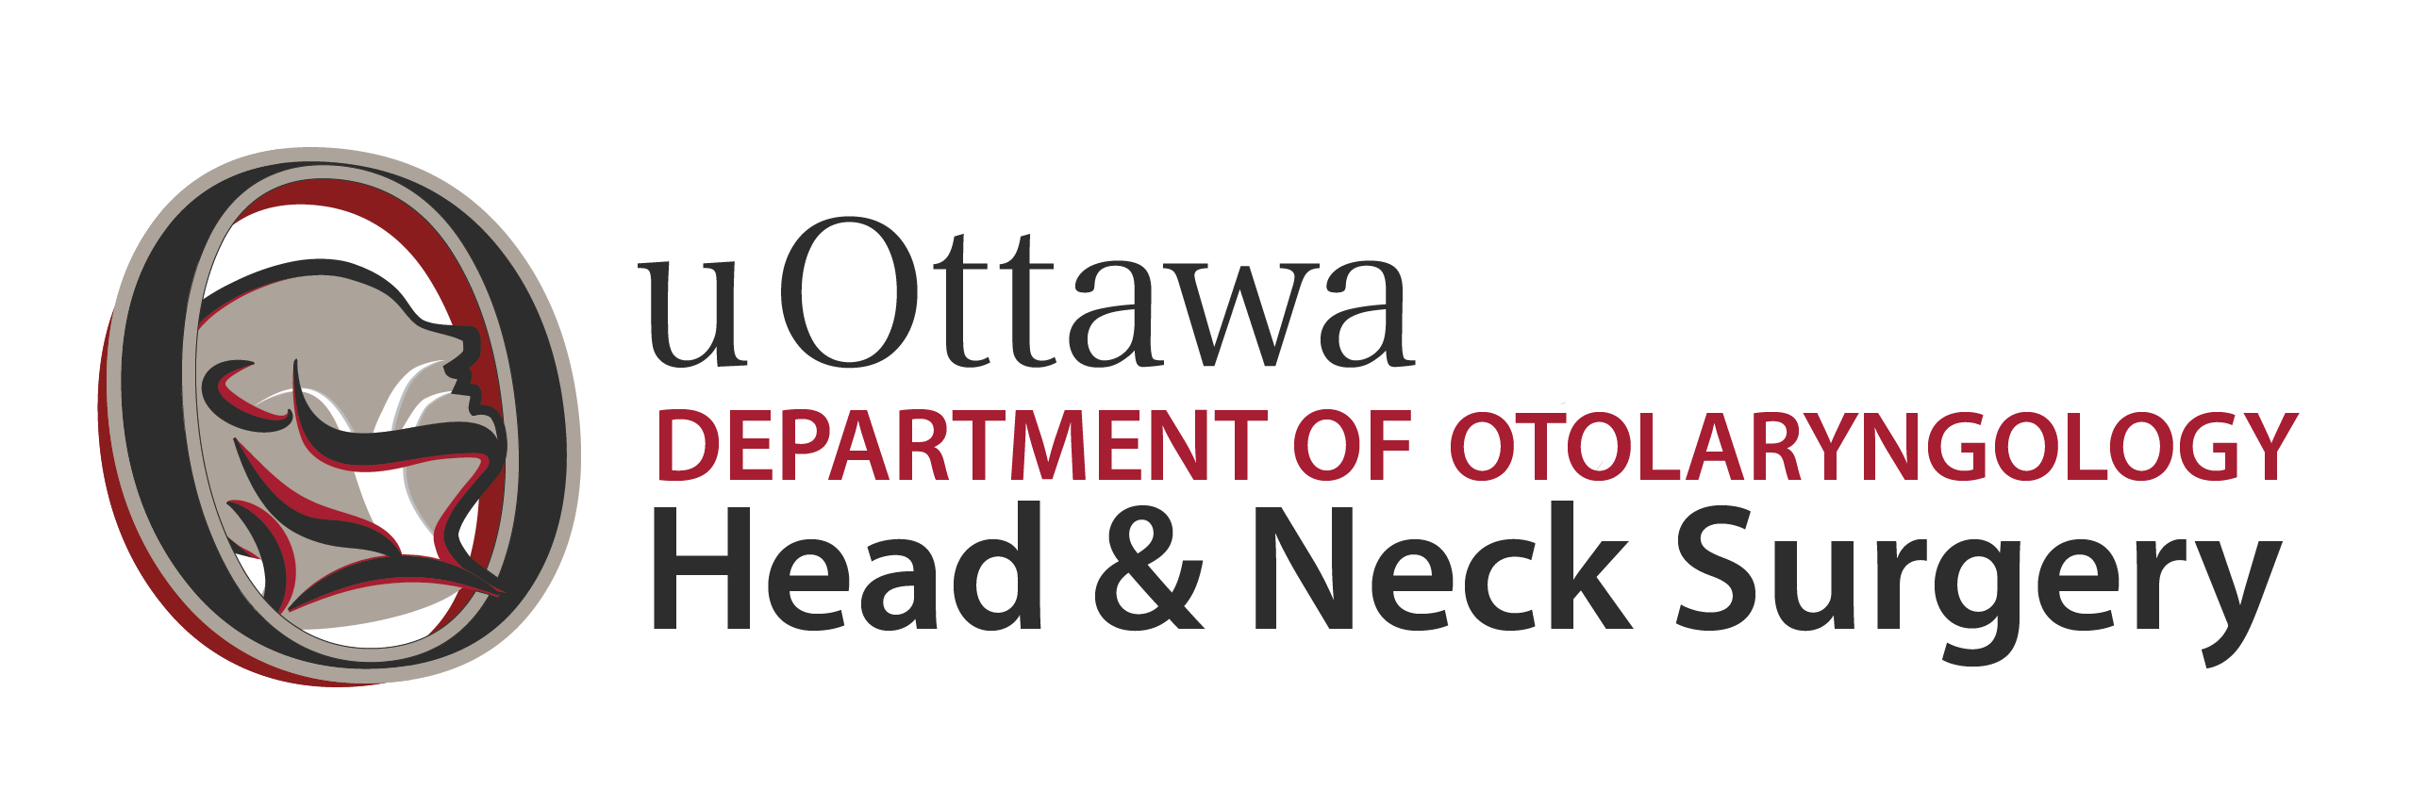
Department of Otolaryngology - Head and Neck Surgery University of Ottawa
Otologist, Department of Otolaryngology - Head & Neck Surgery
The Department of Otolaryngology – Head and Neck Surgery of the University of Ottawa Faculty of Medicine invites applications for the above noted position. The Department of Otolaryngology - Head and Neck Surgery comprises a dynamic group of surgeons who provide outstanding patient care throughout Ottawa and the Champlain LHIN region. The Department of Otolaryngology - Head and Neck Surgery provides world class clinical care while conducting research and innovation that will guide the patient care of tomorrow.
If you are interested in being a member of one of the largest Otolaryngology-Head and Neck Surgery departments in Canada with:
• National leaders in clinical care, education, innovation and research programs that excel in basic science, clinical science and education;
• Full subspecialty representation;
• High quality undergraduate, postgraduate and fellowship training programs;
• Multidisciplinary collaborations: Neurosurgery, Neurology, Thoracic Surgery, Plastic Surgery, Oral/Maxillofacial Surgery, Ophthalmology;
• High quality professionals in audiology and speech-language pathology;
• Collegial and supportive medical school and hospital administration; and
You meet the following qualifications:
• A subspecialty trained otologist dedicated to the effective delivery of clinical services and academic performance in education and / or research in alignment with the mission, vision, values, policies and objectives of the Department of Otolaryngology-Head and Neck Surgery;
• An outstanding record in patient care and teaching, innovation and research;
• An outstanding clinician who is certified by the Royal College of Physicians and Surgeons of Canada (FRCSC), or equivalent;
• Eligible for licensure in Ontario; and
• An ability to communicate in a bilingual environment (French and English) is preferred.

You are invited to forward a letter of interest, CV, and names of three references by October 31st, 2026. In your letter of interest, please clearly outline any meritorious training or accomplishments, in addition to otology fellowship training, as well as your long-term personal goals of practice.

Send your full application to:

Dr. David Schramm MD SM FRCSC FACS
Chair, Department of Otolaryngology - Head and Neck Surgery, University of Ottawa
Office:
The Ottawa Hospital, Civic Campus
Civic Parkdale Clinic, Room 216
1053 Carling Avenue
Ottawa, ON K1Y 4E9
or via e-mail: dschramm@toh.ca

All qualified candidates are encouraged to apply; however, Canadian citizens and permanent residents will be given priority.

